Trade of Metal Fabrication
Module 3: | Plate Fabrication
Unit 3: | Cylinder Fabrication
 | Phase 2

Table of Contents
List of Figures 4
List of Tables 4
Document Release History 5
Module 3 – Plate Fabrication 6
Unit 3 – Cylinder Fabrication 6
Learning Outcome: 6
Key Learning Points: 6
Training Resources: 7
Key Learning Points Code: 7
Energy and Work 8
Conversion of Energy 9
Example 10
Heat Energy 11
Pre-Setting 12
Safety 13
Springback 14
Applications Involving Rolling 15
1. Manual-Geared Bending Rolls 15
2. Powered Bending Rolls 16
Methods of Transferring Patterns to Metal 17
Example Calculation 19
Self Assessment 21
Questions on Background Notes – Module 3.Unit 3 21
Index 22

List of Figures
Figure 1 - The Difference between Heating a Block of Copper and a Block of Steel of Equal Mass 8
Figure 2 - Electric Motor Driving a Lathe 9
Figure 3 - Material being removed from Work-Piece 9
Figure 4 - Joule of Energy 10
Figure 5 - Workshop Crane 10
Figure 6 - Pre-Setting 12
Figure 7 - Positioning of Template on Material to Avoid Unnecessary Waste 17
Figure 8 - Transferring a Paper Pattern on to Metal 17
Figure 9 - Transferring a Metal Template on to Sheet Metal 18
Figure 10 - Bracket 19
Figure 11 - Cylinder 20

List of Tables

Document Release History
Date | Version | Comments
13/12/06 | First draft
13/12/13 | SOLAS transfer

Module 3 – Plate Fabrication

Unit 3 – Cylinder Fabrication
Duration – 7 Hours

Learning Outcome:
By the end of this unit each apprentice will be able to:
- Read and interpret basic fabrication drawing
- Calculate plate dimensions
- Pre-set and roll cylinder as per drawing
- Weld seam – M.M.A.
- Decimal arithmetic (denary system)

Key Learning Points:
D | Read and interpret conventions for cylinder fabrication, e.g. diameters to be rolled, plate thickness, mean diameter.  (Instructor goes through this in classroom).
M | Calculate developed length using π x mean diameter.
P H | Initiative, ability, standard of work, working safely.
Sk Rk | Plate marking  Template marking  Rolling  Tacking and welding
Rk | Levelling of roll, making radial template.
Sc | Reason for pre-setting and over rolling for springback, amount of metal to be pre-set and over rolled.
M | Degree of accuracy – decimal places and significant figures.  (Instructor goes through this in classroom).
Sc | Work – energy and power.

Training Resources:
- Fabrication workshop facilities
- Apprentice tool kit
- Oxy-fuel gas cutting equipment
- Pyramid rolls
- M.M.A. plant
- Welding consumables
- Mild steel plate
- Angle grinder
- Safety equipment
- Protective clothing
- Pressbrake

Key Learning Points Code:
M = Maths D= Drawing RK = Related Knowledge Sc = Science
P = Personal Skills Sk = Skill H = Hazards

Energy and Work
Energy and work are connected. Work is the expenditure of energy. They are therefore both measured in the same units.

The SI unit is the joule (J), named after James Prescott Joule, the British physicist who showed that different forms of energy could be converted into each other without loss or gain of energy.

Because heat is energy, it is measured in joules. The amount of heat taken up by a substance depends on its mass and temperature. The final temperature will depend on the substance's specific heat capacity. Different substances have different specific heat capacities. You can measure this property by giving a substance of known mass a known amount of heat and measuring its rise in temperature.

For example, a piece of copper will gain 50 K in temperature when receiving the same quantity of heat that will produce a rise of only 5 K in the same mass of water. Copper therefore has a specific heat capacity ten times that of water.

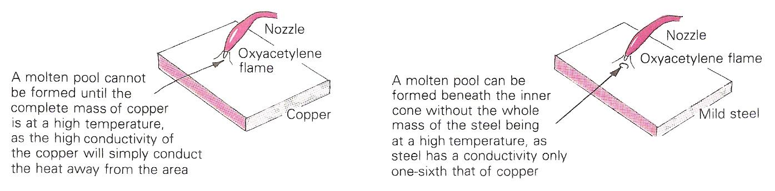
Figure 1 - The Difference between Heating a Block of Copper and a Block of Steel of Equal Mass

Conversion of Energy
Energy can exist in various forms: mechanical, electrical, heat, chemical and nuclear.
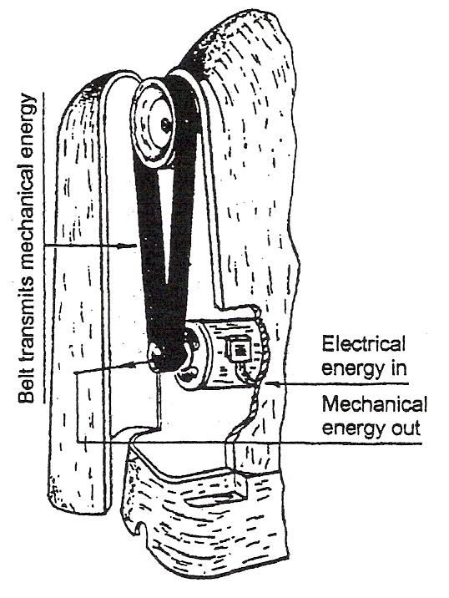
Figure 2 - Electric Motor Driving a Lathe

Figure 2 shows an electric motor driving a lathe. The electrical energy which enters the motor is converted to mechanical energy in the motor, to drive the lathe through the two vee belts that connect the motor pulleys to the drive pulleys.
While material is being removed from the work-piece in a lathe as shown in Figure 3, heat is generated at the tool point, and mechanical energy is converted into heat energy. While energy can be converted from one form to another form, it cannot be created or destroyed.
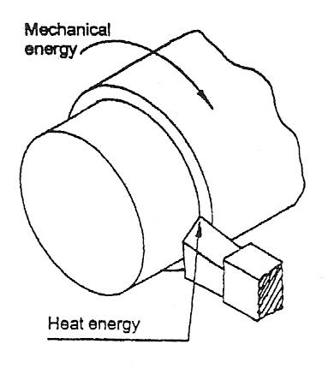
Figure 3 - Material being removed from Work-Piece
The unit of energy is the joule, written J for short. Mechanical energy is used (dissipated) when a force moves through a distance. One joule (J) of energy is used when a force of 1N (Newton) moves through a distance of 1m (metre) as shown in Figure 127.
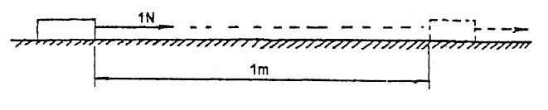
Figure 4 - Joule of Energy

6 Joules of energy are used when a force of 2 N moves 3 m.
24 Joules of energy are used when a force of 6 N moves 4 m.
56 Joules of energy are used when a force of 16 N moves 3.5 m.

Larger units of energy are the kilojoule (kJ) and megajoule (MJ).
1 kilojoule (kJ) = 1,000 joules (J)
1 megajoule (MJ) == 1,000,000 joules (J)

Units of energy required to:
- Shut a door - 5 joules,
- Load a mass of 1 kg into a lathe chuck - 15 joules,
- Climb a stairs - 2,000 joules (2kJ),
- Move a lathe saddle from tailstock to headstock - 80 joules.

Example
A workshop crane as shown in the sketch below is used to lift a mass of 100 kg through a vertical distance of 1.5m.
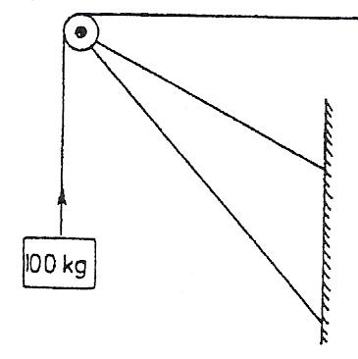
Figure 5 - Workshop Crane
Determine:
- Force on rope in Newtons,
- Energy used in joules.

Solution:
- Mass = 100 kg
Force required to life mass = 9.8 x 100
= 980 N
- Energy used = Force x Distance
= 980 x 1.5
= 1470 Joules

Test Yourself
- Check the force necessary to move the tailstock of a lathe.
- Calculate the energy required to move the tailstock a distance of 0.5 m.
Energy Required = Force x Distance

Answer:
- Force is approximately 100 N,
- Force x distance = 100 x 0.5
= 50 Joules.

Heat Energy
Like mechanical energy, heat energy is measured in joules. There are several workshop examples where mechanical energy is converted into heat energy. When grinding a centre punch or chisel, the tip heats up and it must be plunged into coolant periodically so that the original temper is not destroyed. Coolant is used during a turning operation so that the heat generated at the tool point is removed by the coolant while passing through the cutting zone. The mechanical energy generated at the tool point is converted to heat energy and results in the cool temperature increasing slightly.

Remember

Power is:
- Rate of doing work
- Expressed in Watts (W)
1 Watt = 1 joule/second
1 kW = 1000 W
Horse power is:
- The imperial unit of power
- 1 hp is about 746 W
- Pferdestarke in German (PS)

Pre-Setting
An important aspect of rolling plate and sheet is the pre-forming of the ends, to obtain a true cylinder without flats where the opposite edges touch.

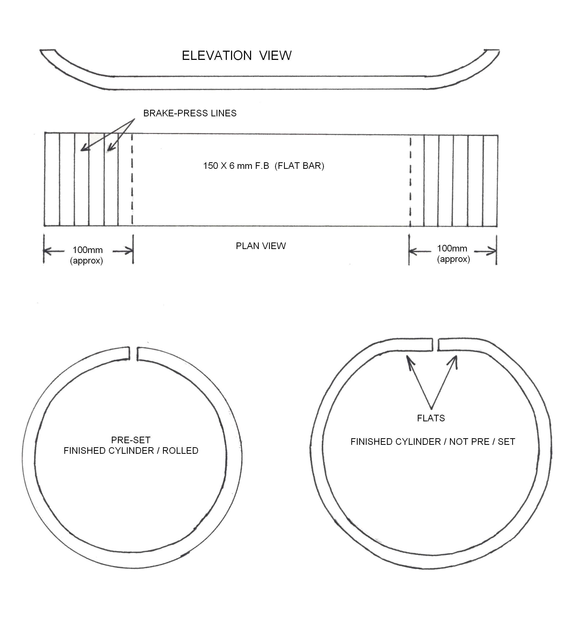
Figure 6 - Pre-Setting

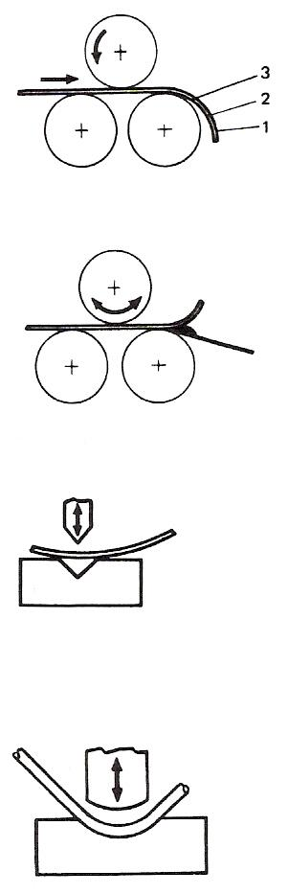
- Using a template to check the curve, hammer the ends over the bottom roller in increments (see the first figure). Thin gauge plate to approximately 6 mm.
- Using a convex bar between the bottom roller and the edge of the plate (see the second figure). Thin gauge plate to approximately 10 mm.
- Vee block and top tool (see the third figure). Thin and thick plate.
- Pressing between blocks (hot or cold) (see the last figure). Very thick plate.
When the cylinder is curved until the ends touch, it is good practice to over-roll slightly (not on very thick hot rolled plate) to allow for the elasticity in the material which "springs back" when the roll pressure is released. It is important that during rolling the weight is applied in small increments. This has the effect of "breaking in" the sheet metal and avoiding kinks in thick sheet.
There are several methods applied on powered rolls for releasing the complete cylinder: locating pin and swinging arm, counter-balanced bearing.

Safety
- Ensure that guards are in place and that you know where the emergency stop button is for powered rolls.
- Keep fingers clear of rollers when in motion and do not wear gloves.
- Ensure that no-one is liable to be struck by the moving plate or that the plate falls out of the rollers.
- Do not allow edge of plate to run through hands because of sharp edges.

Springback
During the bending of a material an unbalanced system of varying stresses is produced in the region of the bend. When the bending force is removed (on completion of the bending operation) this unbalanced system tends to bring itself to equilibrium. The bend tends to spring back, and any part of the elastic stress which remains in the material becomes RESIDUAL STRESS in the bend zone.

The amount of springback action to be expected will obviously vary because of the differing compositions and mechanical properties of the materials used in fabrication engineering. Some materials, because of their composition, can undergo more severe cold-working than others. The severity of bending a specific material depends on two basic factors:

- The radius of the bend.
- The thickness of the material.

A 'tight' (small radius) bend causes greater cold deformation than a more generous bend in a material of the same thickness.

A thicker material develops more STRAIN HARDENING than is experienced in thinner material bent to the same inside radius.

The 'condition' of the material upon which bending operations are to be performed, has an influence on the amount of springback likely to result. For example, using the same bend radius, a COLD-ROLLED NON-HEAT-TREATABLE aluminium alloy in the 'HALF-HARD' temper, or condition, will exhibit greater springback than the same alloy of equal thickness when in the 'FULLY ANNEALED' condition.

The limit to which free bending can be carried out is determined by:

- The extent to which the material will stretch (ELONGATE) on the tension side (outside of bend).
- The failure due to such COMPRESSIVE EFFECTS as buckling, wrinkling or collapse on the inside of the bend in respect of hollow sections (pipe bending).

Applications Involving Rolling

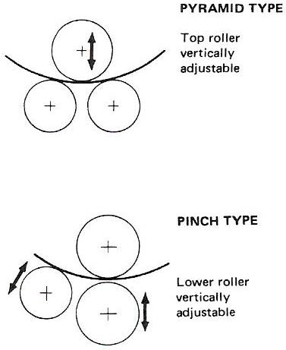

There are several types of rolls for curving thin sheet, thick plate and angle sections, but most are based on the Pyramid or Pinch type of rolls (see the two figures shown here).

The following is a selection of common types of rolls with typical applications.

1. Manual-Geared Bending Rolls
These may be pinch or pyramid and, for sheet metal work, grooves are cut circumferentially around the roll or at one end for bending rod and rolling wired edges. After securing, the top roller is either swung out or the top bearing housing lowered to allow rolled containers to be withdrawn. The top roller (depending on the make) may be positioned at an angle to the lower rollers to form cones. In this type of roll, capacity ranges from gauge plate to approximately 5 mm thick sheet. Parallel grooves are cut lengthways on the heavier type bottom rolls to help with the lining-up of plate edges and to facilitate scale removal.

2. Powered Bending Rolls

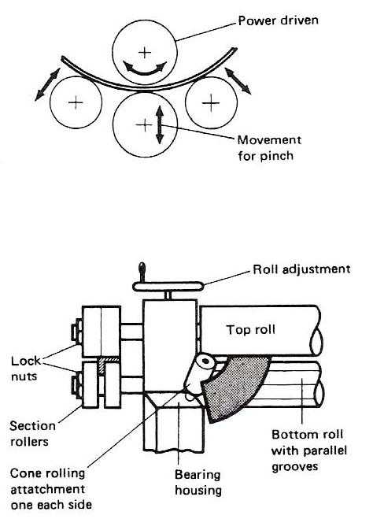
Again, these rolls may be of the pyramid or pinch type or a variation of these. They often have a power-driven top roller for vertical adjustment, and powered bottom rollers for rotation. For curving very heavy plate, there are often four rollers with the upper roller powered for rotation and the front and back ones supplying the curving pressure (see the top figure).
Cones may be formed by adjusting the front roller or, on the pyramid type, by use of a cone rolling attachment or by sloping the top roll. For rolling sheet metal cones, a type of roll consisting of a conical-shaped top and bottom roll, open ended, is used.
Some machines have an additional attachment for rolling angle and bar sections. This attachment is an extension of the rolls, but positioned outside the bearing housing (see the bottom figure).
Applications include structural work, boiler plates, ships frames, circular and curved tanks and containers and gas holders for heavy work; and circular sheet metal containers such as food dishes, cans and domestic ware.
An important aspect of rolling plate and sheet is the pre-forming of the ends, to obtain a true cylinder without flats where the opposite edges touch. Pinch rolls are designed to eliminate these flats at the start of the rolling operation, but other methods have to be employed when pyramid rolls are used.

Methods of Transferring Patterns to Metal
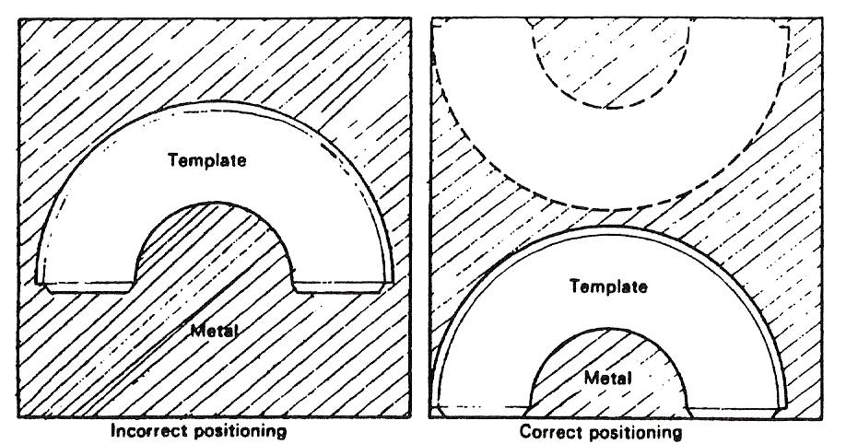
Figure 7 - Positioning of Template on Material to Avoid Unnecessary Waste

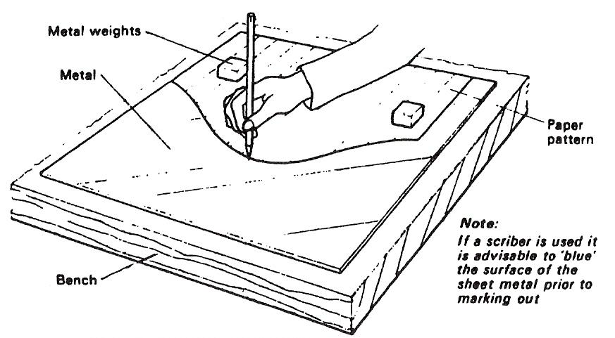
Figure 8 - Transferring a Paper Pattern on to Metal

- P1ace the sheet of metal to be used on the surface of the bench and position the paper to avoid waste.
- To prevent the paper from creeping hold it in position with metal weights.
- With a hard sharp pencil or scriber scribe the outline of the pattern on the sheet metal.
- Remove the weights and the pattern and cut the metal to the outline scribed upon it using universal hand shears removing all burrs with a suitable file.
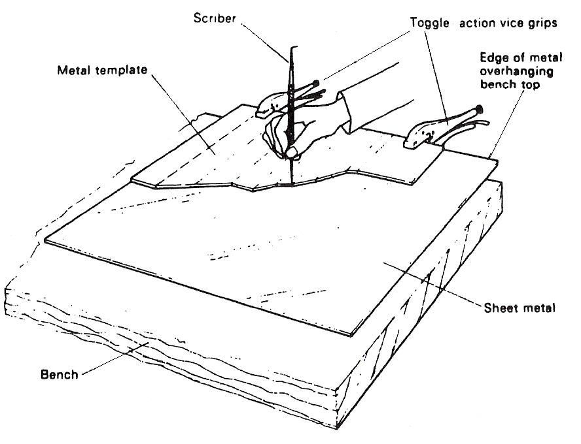
Figure 9 - Transferring a Metal Template on to Sheet Metal

- Place the sheet of metal to be used on the bench with one of its squared sides slightly overhanging.
- Position the metal template in position as shown, and clamp it securely with vice grips to restrain any movement.
- Scribe the outline of the template on the sheet metal, using a sharp scriber.
- Release vice grips to remove template and cut the sheet metal to the outline scribed upon it with a suitable pair of hand shears. Remove all burrs with a file.

Example Calculation
Take π as 3.142 and material as low carbon steel (normalised).
(It should be noted that other methods are used in conjunction with B.A. tables.)
Examples showing the neutral line are shown in Figure 10 and Figure 11.

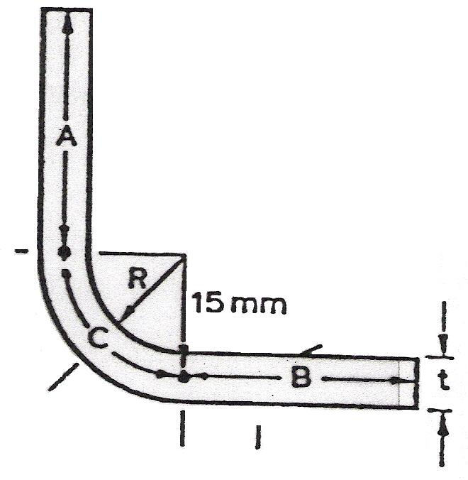
Figure 10 - Bracket

Bracket
To produce length of flat required:
t = 6 mm
A = 20mm
B = 20mm
C = 23.56 (calculated)
R = 2 x t = 12mm
Calculated length C = π x mean diameter 4 (quarter circle)
C = 3.142 x 30 = 94.26 4 = 23.56 mm
Length of flat required = A+ B + C
= 20 + 20 + 23.56
= 63.6 mm
Cylinder
Take π = 3.142
t = metal thickness = 3 mm
A = outside diameter = 116 mm
B = inside diameter = 110 mm
C = mean diameter = 113 mm (measured to neutral line).
Length of flat required
= π x mean diameter
= 3.142 x 113 = 355 mm

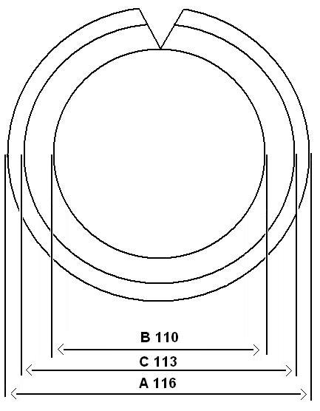
Figure 11 - Cylinder

Self Assessment

Questions on Background Notes – Module 3.Unit 3

No Suggested Questions and Answers.

Index

A
Applications Involving Rolling, 16
1. Manual-Geared Bending Rolls, 16
2. Powered Bending Rolls, 17
C
Conversion of Energy, 10
Example, 11
E
Energy and Work, 9
Example Calculation, 21
H
Heat Energy, 12
M
Methods of Transferring Patterns to Metal, 18
P
Pre-Setting, 13
Safety, 14
S
Springback, 15

